How to record a Class Collaborate session, download a recording, and add a recording to a course module

To record a Collaborate session
- Locate a Collaborate session. Click the option icon and choose “Edit settings”:
- Click the gear icon and check the box to “Allow recording downloads”:
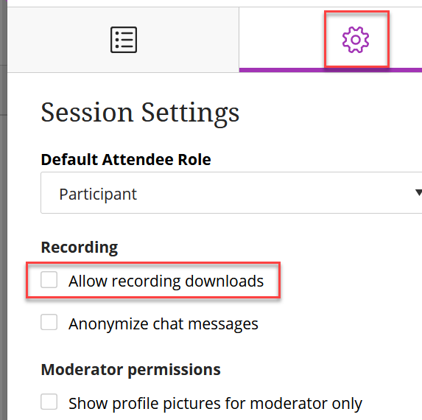
- As you enter the session, Collaborate asks if you want to start the recording. You may click the ‘record’ link to start the recording, or you may click the option icon at the top left of the screen and start recording whenever you are ready:
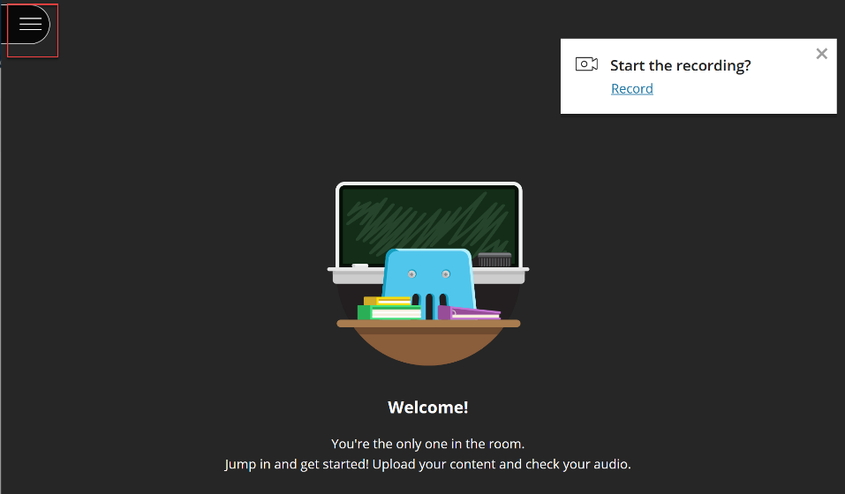
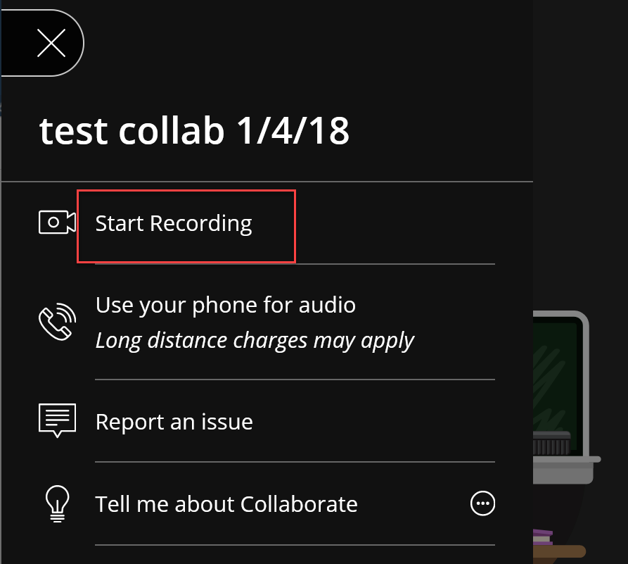

Once the session is being recorded, you will see the red camera icon displayed:
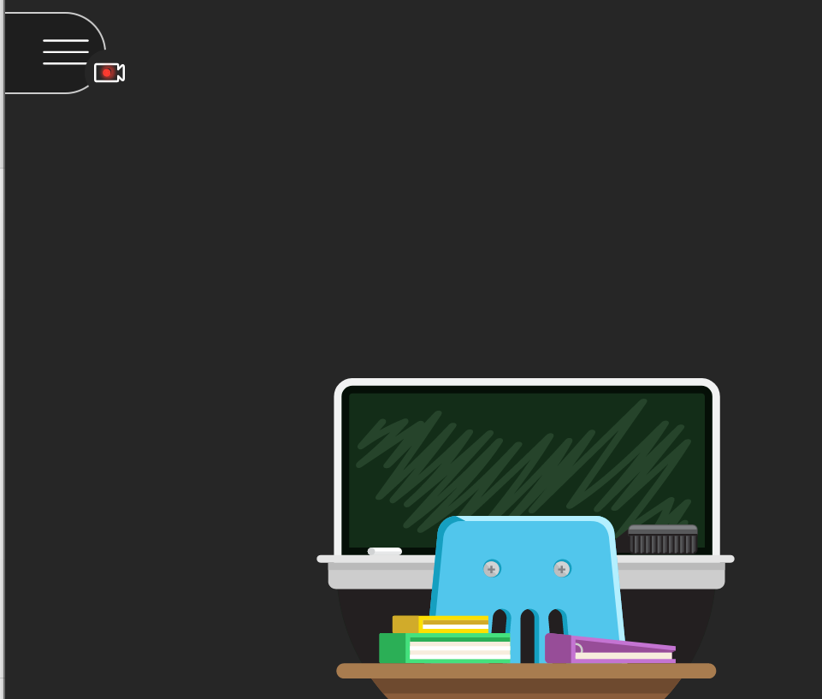

- To stop recording, simply click the option button at the top left of the screen and choose “Stop Recording”:
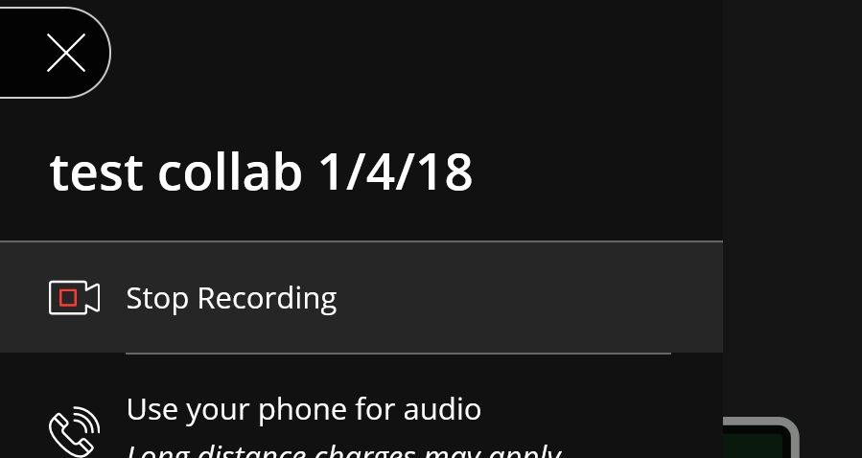

To download or copy a Collaborate recording
Once the recording has stopped, it may take a few hours for the recording to populate to your Collaborate homepage.
- To find a recording, click the option button:
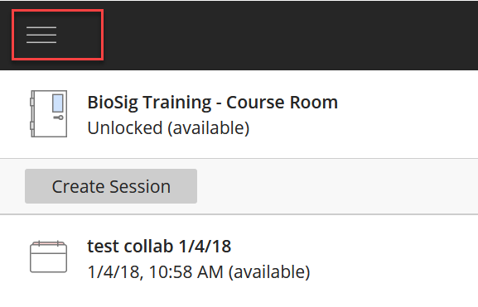
then choose “Recordings”:
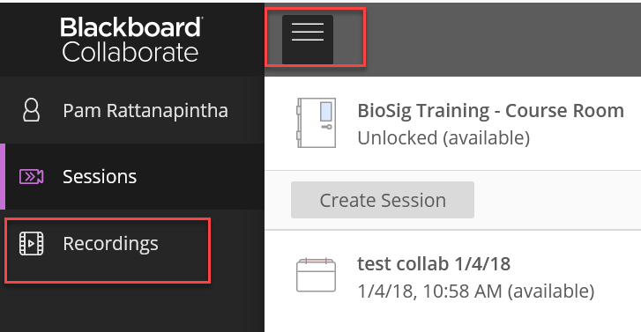

- Once you locate the recording, click the option button at the right of the recording, and select “Recording settings”:
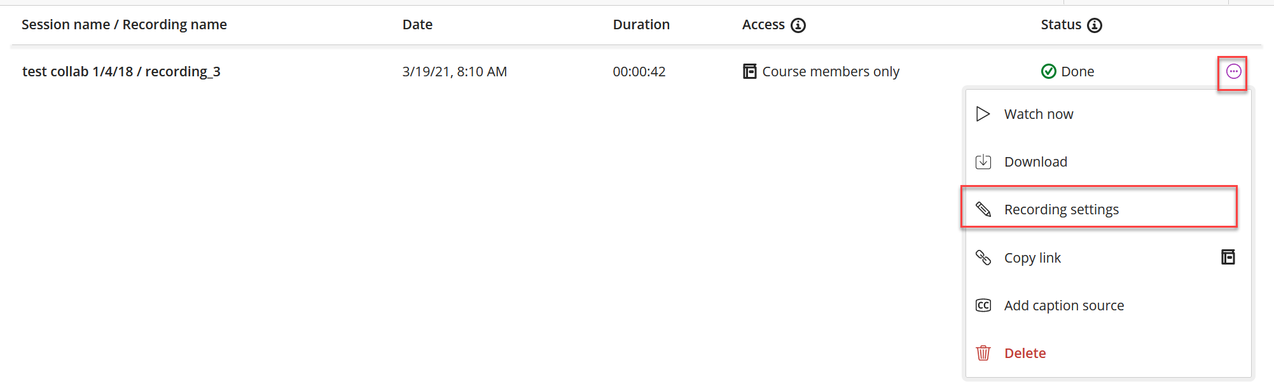
- Check the box to “Allow public access”:
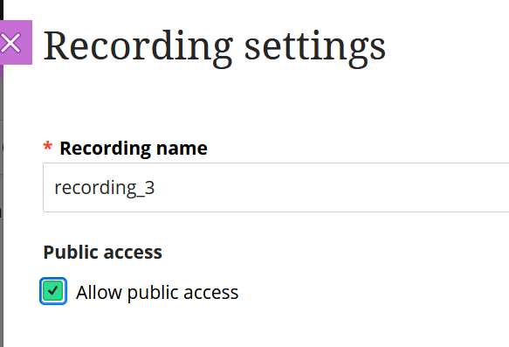

To add a recording to your course module
- Click the option button at the right of the recording. Click “Copy link”:
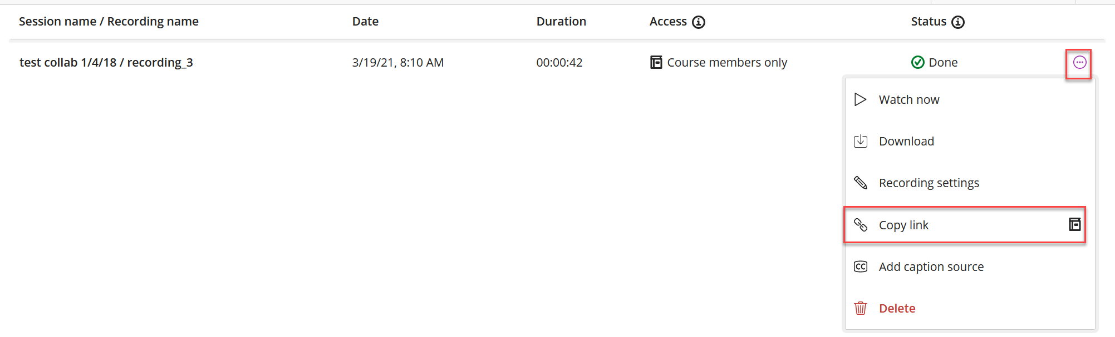

- Navigate to the area in your course where you would like to add the recording. Click “Build Content”, and click “Web Link”:
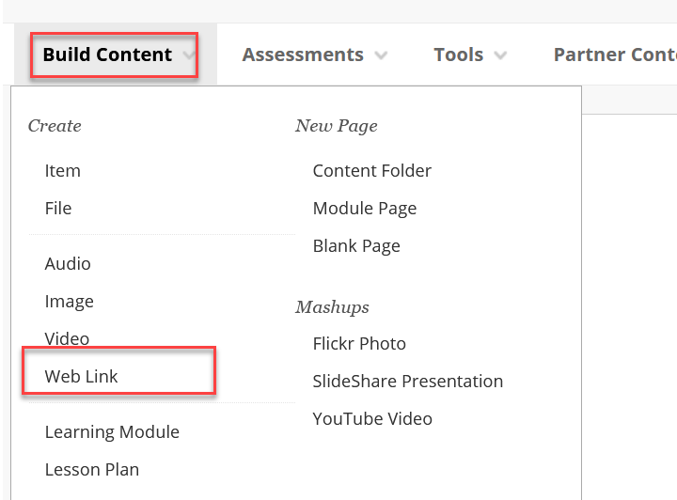

- Enter the name and click Control V on the keyboard to paste the copied URL into the URL box, and click Submit:
