BioSight-ID Exam Monitoring Policy Recommendations

- A device that meets current system requirements:
  - System not older than 5-years when possible
  - 2GHz processor or faster
  - 1GB free memory or greater
  - 20GB free storage space or greater
  - 256kbps Internet connection or faster
  - 1024×768 or greater resolution monitor
  - Videocard with modern WebGL support
  - Webcam and microphone
- Take test from a well-lit, quiet room, free from distractions and clutter (no adults, children, or pets can be present).
- No headphone or headsets allowed.
- High-speed internet connection.
- Do not get up and leave your desk or sight of your camera. Take care of any nutrient requirements and nature calls before you start the session.
- Please refer to your syllabus or instructor if external notes or tools are prohibited.

BioSight-ID Filters

- Show Infractions % between
  - Recommend faculty view anything above 20%
- Show Session times between
  - Minimum of 5 minutes
    - Anything less than 5 minutes could indicate:
      - Student closed BioSight-ID early
      - Technical issues
- New search showing “ANY” of two faces
  - This will give any recording that detected two faces
- New search showing 5% of no faces
  - This will give any that recordings that detected no faces 5% of the time
- New search showing 30 audio level
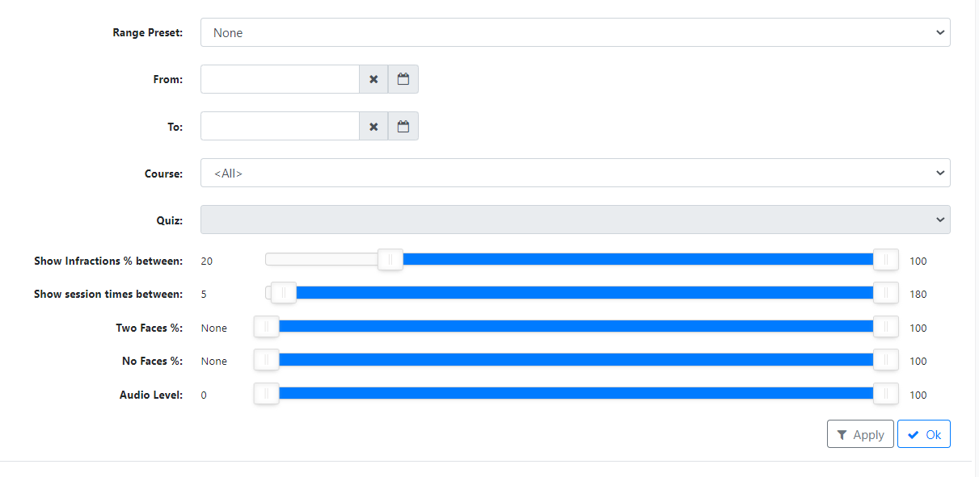
  - This would indicate speaking level

All decisions should ultimately be made by faculty. We recommend contacting the student for an explanation or requiring a retest any time 2 faces appear or the student clearly leaves the view of the camera. Additionally, the confidence level will start to decrease when the student is looking down or away from the camera. This could indicate looking at note and would require discretion from the instructor about a retest.
How to View Activity

After setting search filters, click the blue “View” button on the student.

After the blue “View” button is clicked, this is what the dashboard will look like:
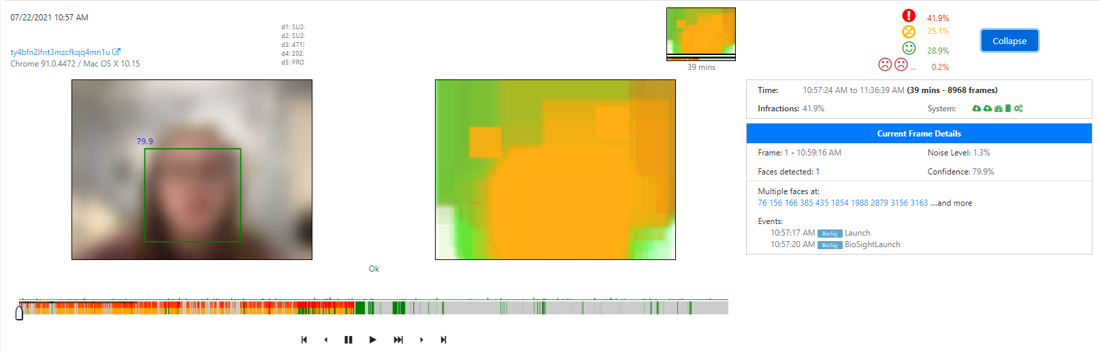
The play button below the video will play the recording, or the scroll bar can be used to quickly scroll through the recording.

The infractions are shown in the upper right corner, as well as below the recordings. Red is an infraction. Gray is a grace period. Green is good.

If there are any questions, you can direct them to Amber Merrill, Sr. Director of BSI Services, at amber.merrill@biosig-id.com.

BioSight-ID Dashboard Definitions

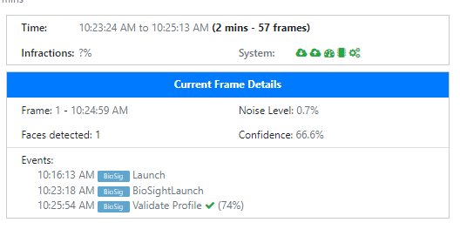
Time – the length of time the student was recorded
Infraction % - the total % of infraction time
System – gathered from the system test done before BioSight-ID loads
Download Speed (in Mbps)
Upload Speed (in Mbps)
Video Card WebGL Support Detected (true/false)
CPU Speed Test (in seconds)
Static Face Speed (time in milliseconds to detect static face sample)

Current Frame Detail – tells the details of the current frame on the recording
- Frame is the current frame.
- Noise level is the current noise level.
- Faces detected tells the number of faces detected.
- Confidence is the confidence level that a face is currently detected.
  - This number is also shown on the green box.
  - The confidence level will go down as the student looks away or down.
Events – tells when the student interacts with BioSig-ID to include Launch, BioSightLaunch, Validated Profile, Resetting Profile.

