Colleague/Blackboard Crosswalk
If you are having trouble correlating the course information in Colleague and Blackboard, try the following steps:
At the Institution Page in Blackboard, select Lookup your Course Section from the Faculty Resources box.

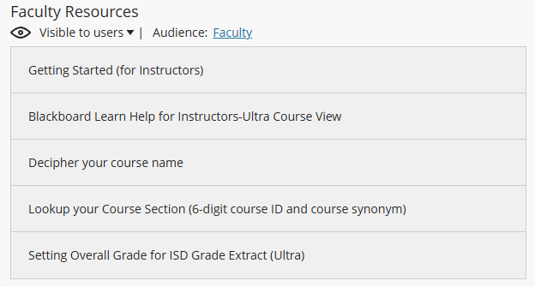

You will see this screen where you can look up your course by 6-digit section ID, section name, or synonym:

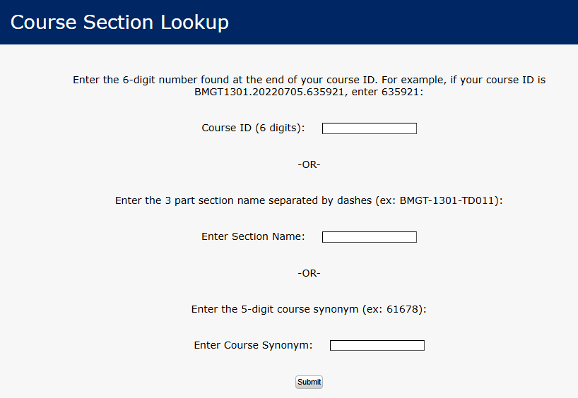

This example is for a TD section number, which means the course is scheduled as online (may be self-paced or non-self-paced).

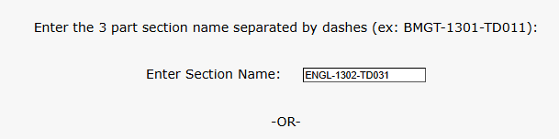

This shows the Blackboard ID (ENGL1302.20250310.664328) , section name, synonym, delivery method, start date, end date, course length, and instructor:

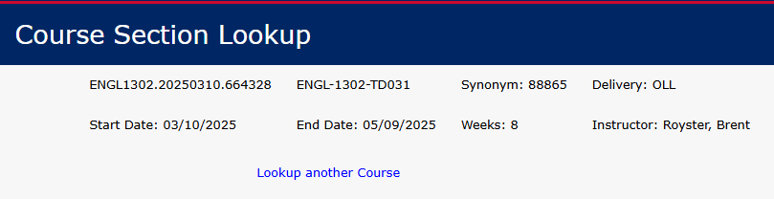

TM section numbers indicate the class is scheduled as lecture or blended and is offered at Central Campus. TH is used for Ft. Cavazos classes and TS is used for Service Area classes.

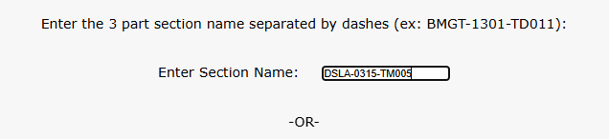

Result:

