Colleague/Blackboard Crosswalk
If you are having trouble correlating the course information in Colleague and Blackboard, try the following steps:
At the My Institution page in Blackboard, select Lookup your Course Section from the Faculty Resources box.

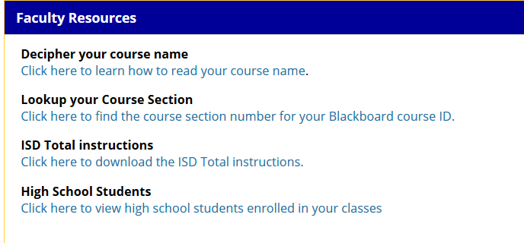

You will see this screen:

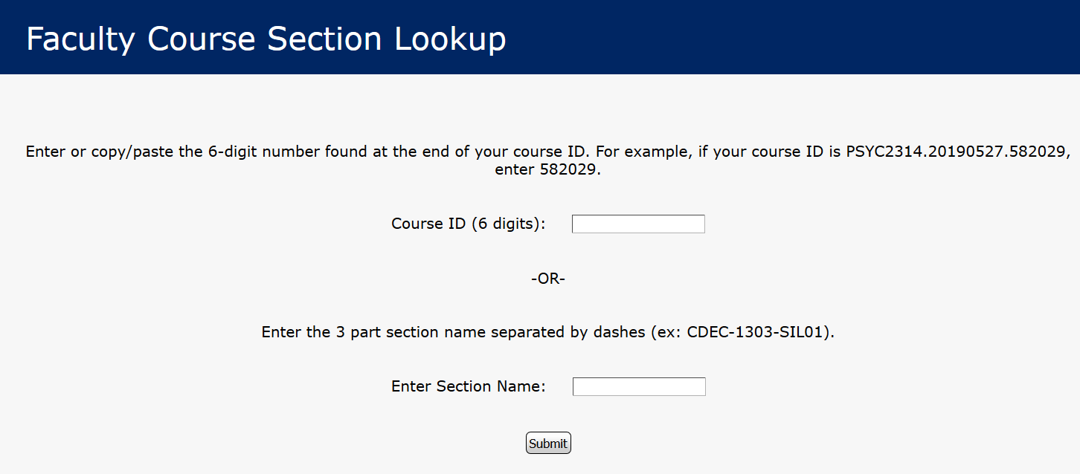

This example is for a TD section number, which means the course is scheduled as online (may be self-paced or non-self-paced).

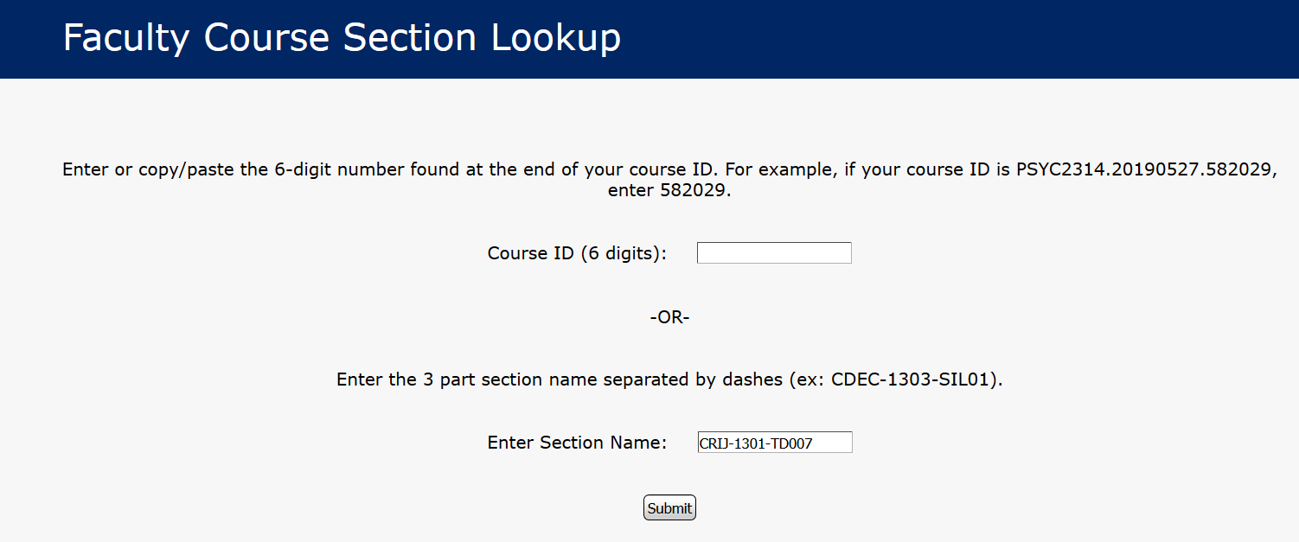

This shows the Blackboard ID (CRIJ1301.20200615.599525) , delivery method, start and end dates, course length.

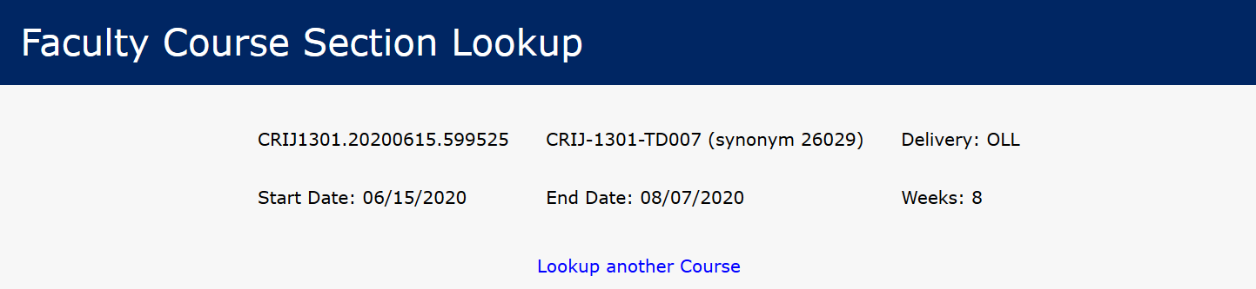

TM section numbers indicate the class is scheduled as lecture or blended and is offered at Central Campus. TH is used for Ft. Hood classes and TS is used for Service Area classes. You may also see things like D207, N178, T208, or U199. These codes are for subsections and reference tuition rates. Blackboard combines all of these subsections under the primary section so you see only one course. Do not use these subsection codes on the course section lookup screen.

