1. Within Blackboard, click on your name at the top-right hand corner of the screen. Then click on “Edit Notification Settings” from the drop down menu.
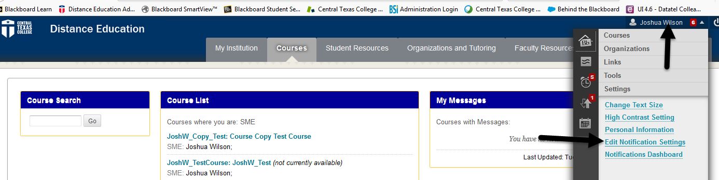
2. Click on “Courses I am teaching”
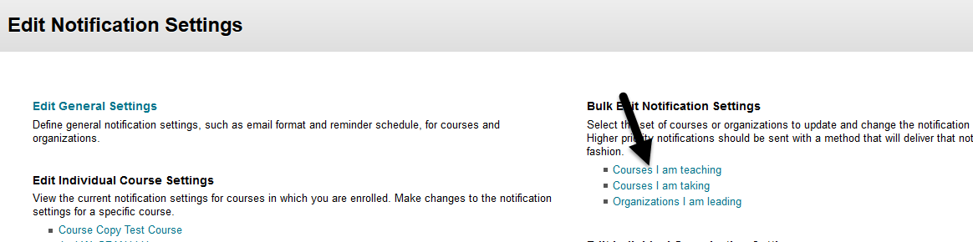
3. From this screen, you can select which courses you would like to change notification settings for and which notifications you would like to receive. To change settings for all courses choose “All”.
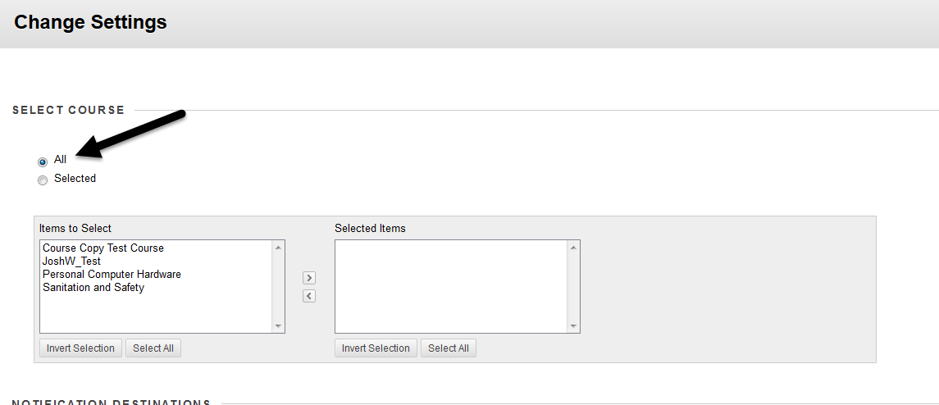
4. Notifications can be set for different actions in Blackboard.
Dashboard notifications will be shown in Blackboard when you click on your name in the upper-right hand corner.
Email notifications will be sent to the email associated with your Blackboard account.
Mobile notifications will not work as we do not attach phone numbers to Blackboard accounts.
A checked box indicates that you will receive notifications while an unchecked box indicates you will not. 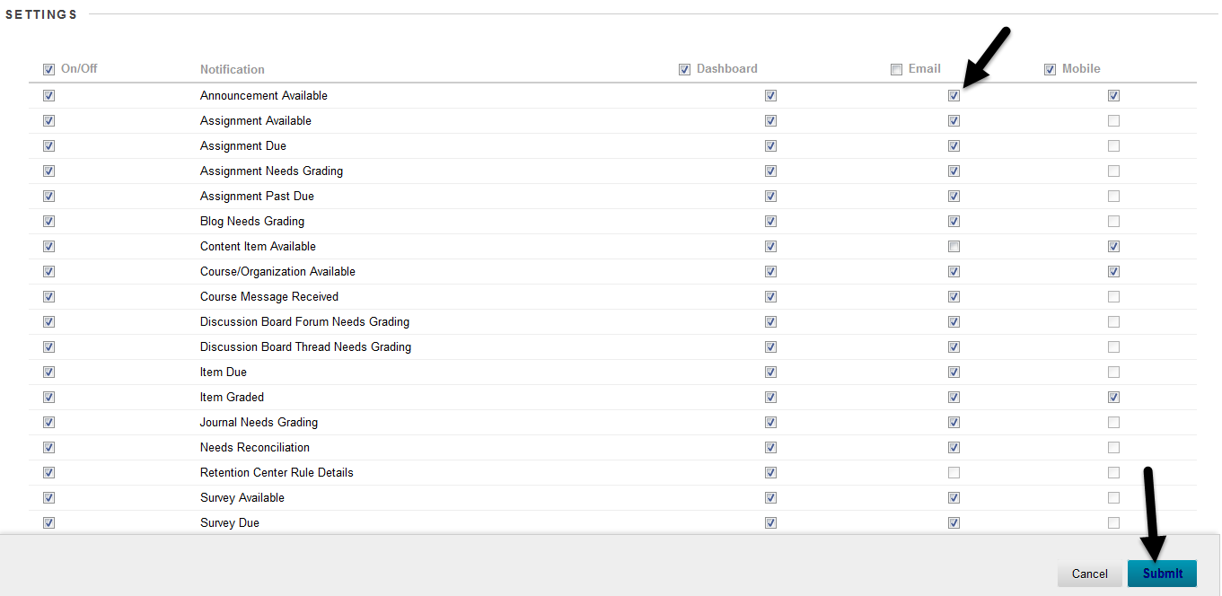
Once you have finished with your selections press the “Submit” button.

