**How to add Concourse Syllabus in a Blackboard course**

1. In your Blackboard course, click “View course & Institution tools” under Books & Tools:

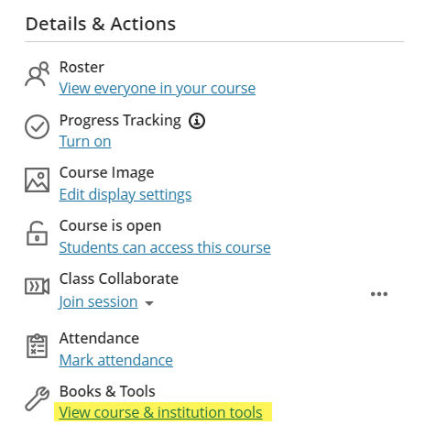

1. Click on the ‘+’ in front of ‘Concourse Syllabus’ to add the syllabus to your course:

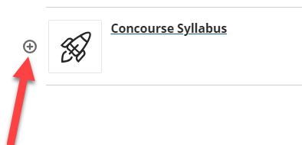

1. The syllabus is now added to the course content.

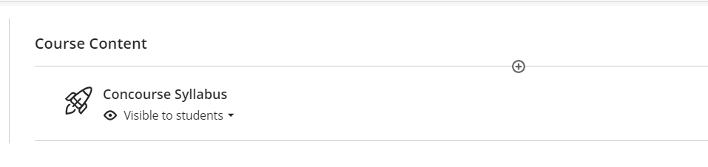

1. Click on the Concourse Syllabus link to view the syllabus and make necessary changes.

For Concourse assistance, users can search the [Knowledge Base](https://support.campusconcourse.com/portal/en/kb) and/or [submit a helpdesk ticket](https://support.campusconcourse.com/portal/en/newticket).

(Last updated 6/12/2024)