**How to enroll in Tutoring organization**

1. Log into your Blackboard account and click on the “Assist” menu at the bottom left of the page, and locate “Math Tutor or “PROWL”:

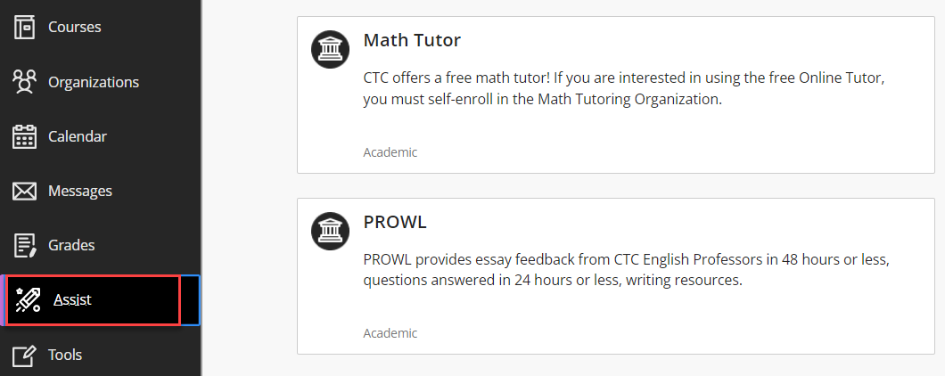

2. Select tutoring organization (Math Tutor or PROWL) you wish to enroll, and click Submit:

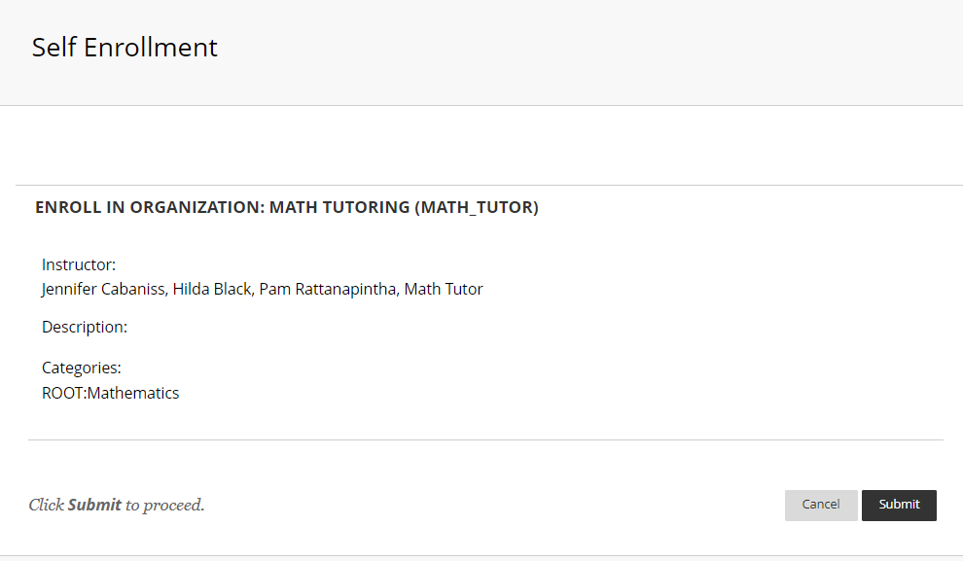

Once enrolled, the tutoring organization can be found under “Organizations” tab:

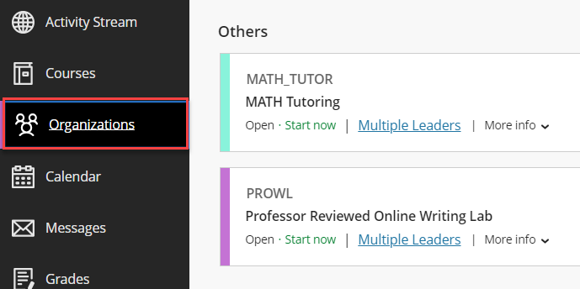

Last updated 6/11/2024