How to export your course

- On the Course Content page, open the menu on the right side above the content list. Select Export Course Package.

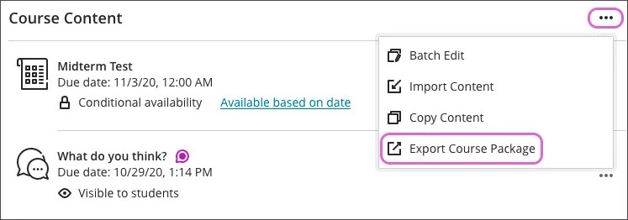

- Select No if you only want to copy the content without the student enrollment and data.
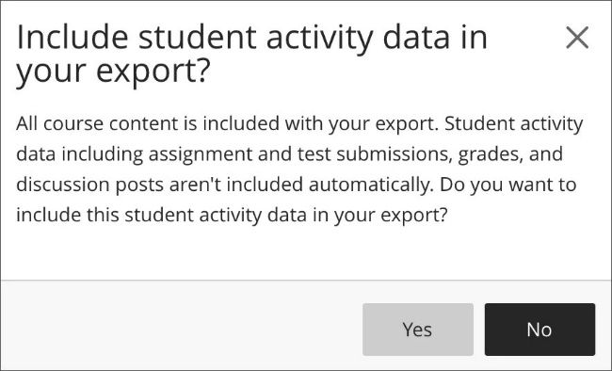

- When the export or archive package is ready, the ZIP file appears. Select the file name to download the package to your computer.
