In order for students to access Collaborate, you will need to add the tool to a content area. Here’s how:
1) Click the Plus sign at the top of the course menu,
and select “Content Area”.

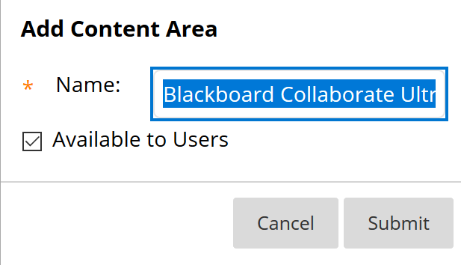
2) Type in the name “Blackboard Collaborate Ultra”, check “Available to Users”, then submit.

3) Select “Blackboard Collaborate Ultra” from the course menu. Select “Tools” > “Blackboard Collaborate Ultra Experience”, then type in the name and click Submit.

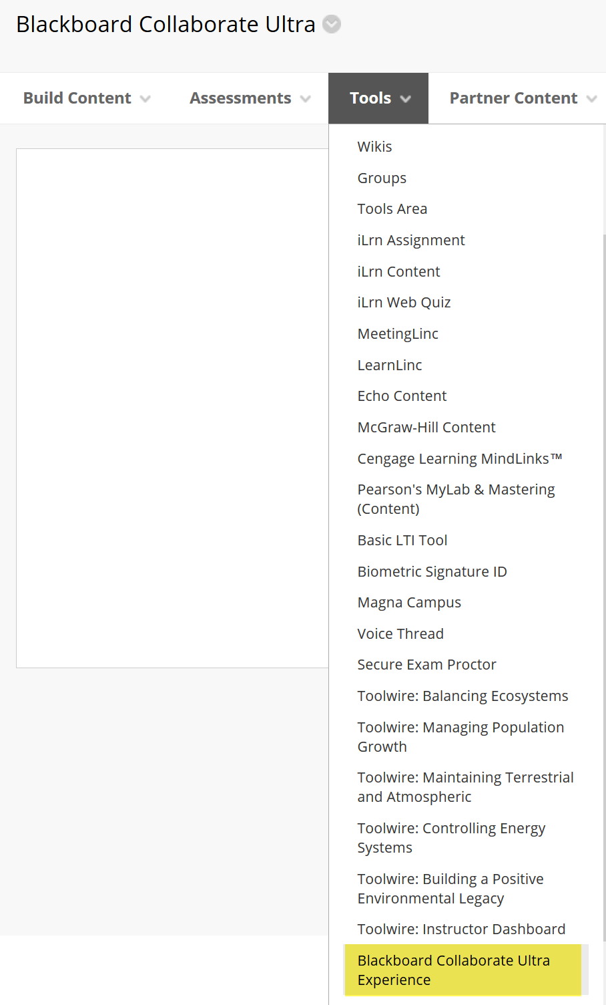

4) Now that the tool is available to students, they will need to the click on the link “Blackboard Collaborate Ultra” to access it.

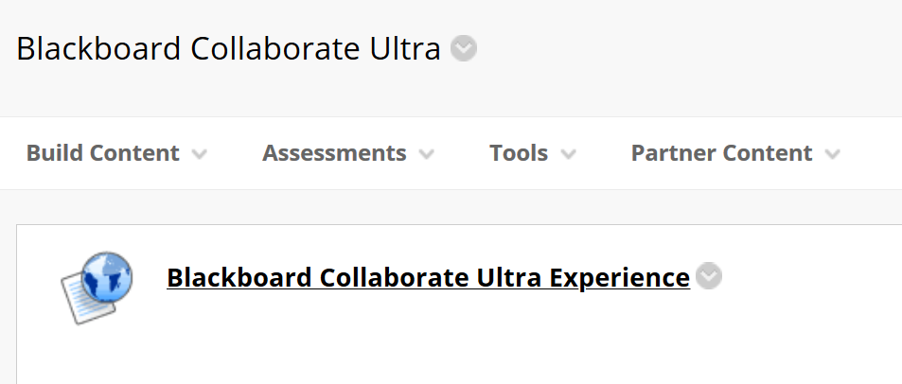

5) Instructor will need to create a meeting session in order for students to join.

To learn more about Collaborate, please visit:

https://support.class.com/s/collaborate?language=en_US&articlenumber=kA08a000000E6XDCA0&callchild=true&isload=true

Your students can learn how to use Collaborate from this link:

https://support.class.com/s/collaborate?language=en_US&articlenumber=kA08a000000E6d1CAC&callchild=true&isload=true

