How to Create a Rule for Students Unable to Create a BioSig

1. Click on the drop down box next to the assignment you would like to exempt student(s) from using BioSig, and select “Adaptive Release Advanced”. The students will have to create a BioSig unless they are included in the rule.
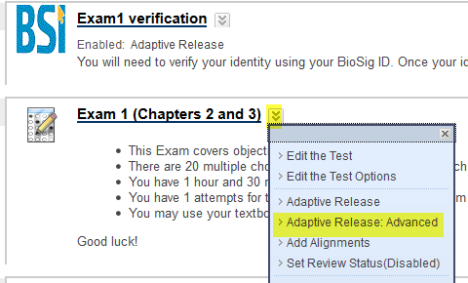

2. Click on Create Rule.
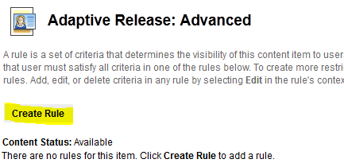

3. Name the rule and click Submit.
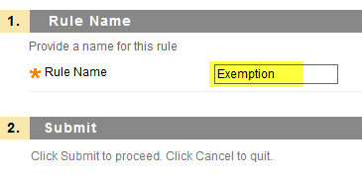

4. Click “Create Criteria”, and choose “Membership”.
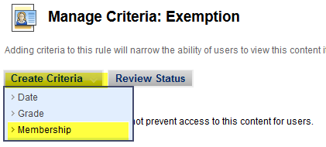

5. Add the Course User that does not have access to BioSig and Submit. If you are unsure of the student’s Username, click on Browse.
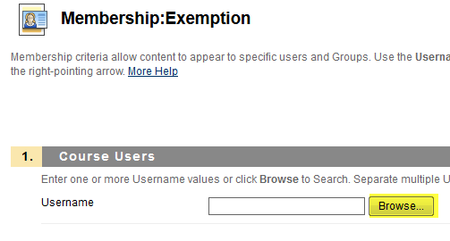

6. The search will default to “Username” and “Contains”. Click “Go.”
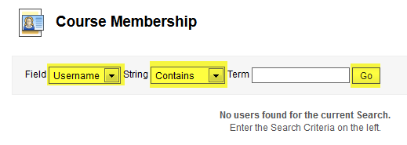

7. Select student(s) who will be exempted from BioSig, and click Submit.
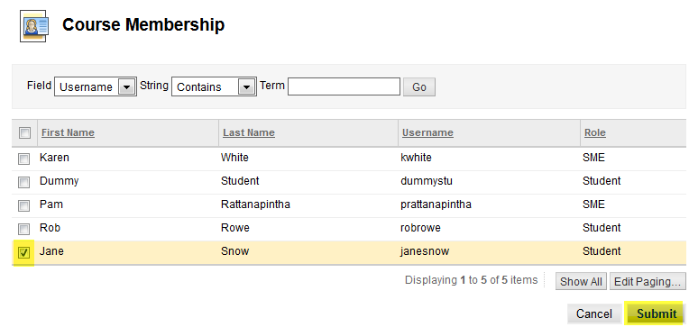

8. Your final Adaptive Release: Advance should look like this
